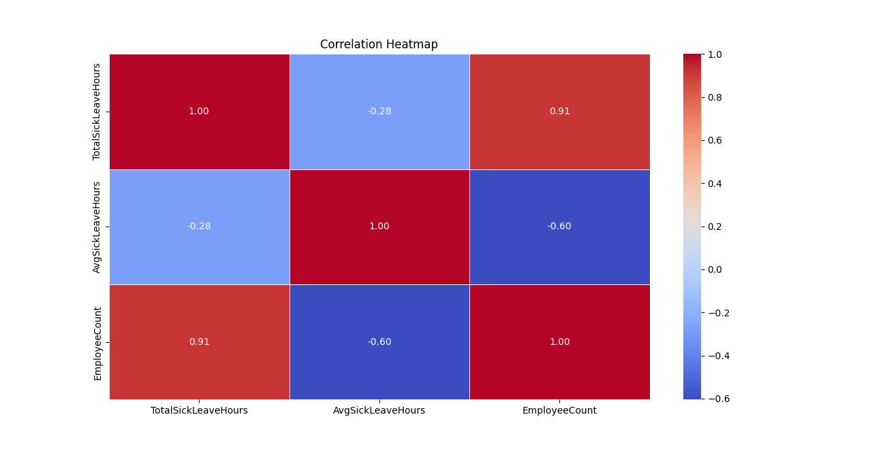
This correlation heatmap highlights the relationships between Total Sick Leave Hours, Average Sick Leave Hours, and Employee Count:
- Strong Positive Correlation (0.91):
  - Total Sick Leave Hours and Employee Count are highly correlated, indicating that departments or job roles with more employees tend to have higher total sick leave hours. This is expected, as more employees contribute cumulatively to the total sick leave.
- Moderate Negative Correlation (-0.60):
  - Average Sick Leave Hours and Employee Count show a moderate negative correlation. This suggests that larger teams tend to have a lower average sick leave per employee, possibly due to workload distribution or differing job responsibilities.
- Weak Negative Correlation (-0.28):
  - Average Sick Leave Hours and Total Sick Leave Hours have a weak negative correlation. This indicates that a higher total sick leave does not necessarily translate into higher average sick leave per employee.
In summary, the data reveals that while larger teams contribute significantly to total sick leave hours, the individual average sick leave tends to decrease as team size grows. This insight can help in assessing workforce health trends and planning interventions.

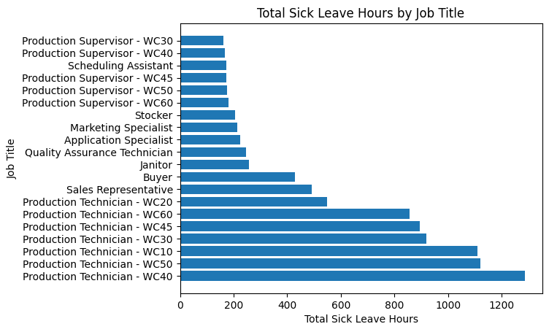
This chart shows the total sick leave hours categorized by job title, highlighting differences in how sick leave is distributed across roles. At the top of the list, Production Technicians in WC40 stand out significantly, with the highest number of sick leave hours—exceeding 1,200. Other Production Technicians in categories like WC50, WC10, and WC30 also report notably high sick leave, although lower than WC40.
In contrast, roles like Production Supervisors across various categories (e.g., WC30, WC40, WC45, WC50) and administrative roles like Scheduling Assistants show much lower sick leave hours, staying well below 200. Similarly, specialized roles such as Marketing Specialists, Application Specialists, and Quality Assurance Technicians also report lower sick leave.
This pattern may indicate that production-heavy roles, particularly those categorized under WC40, face higher physical demands, workplace stress, or environmental factors contributing to greater sick leave usage compared to supervisory or office-based positions.

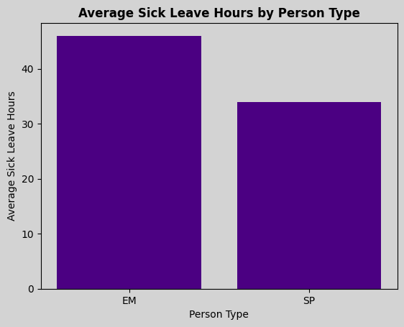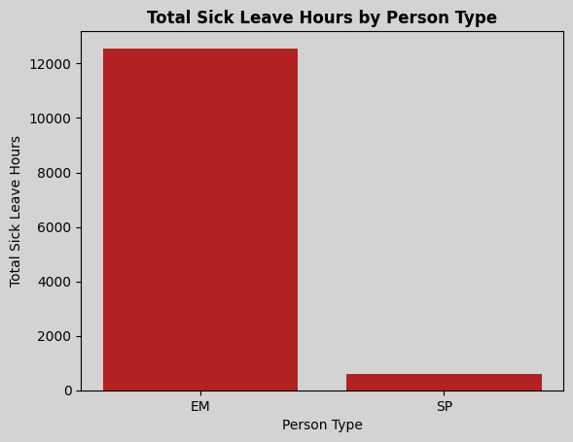

The two bar charts provide insights into the sick leave patterns of two distinct person types: EM (likely employees) and SP (likely subcontractors or part-time staff).
- Average Sick Leave Hours (First Chart):
  - EM individuals took an average of over 40 hours of sick leave.
  - SP individuals took comparatively less, with an average of around 30 hours.
  - This suggests that, on average, EM individuals tend to use more sick leave compared to SP individuals.
- Total Sick Leave Hours (Second Chart):
  - The total sick leave hours for EM is significantly higher, surpassing 12,000 hours.
  - In contrast, SP collectively took much less, with a total of under 2,000 hours.
  - This difference may be attributed to the larger number of EM individuals or the nature of their roles leading to higher overall sick leave usage.
Key Takeaway:
The EM group not only has a higher average of sick leave hours per person but also accounts for a much larger total sick leave usage. This indicates a need to investigate potential causes, such as differences in job roles, working conditions, or health policies, to address any inefficiencies or support requirements.

